# **Ensemble Deep Learning for Diabetic Retinopathy Diagnosis: A Hybrid Approach with Res Net, Efficient Net, Inceptionv3, And Dense Net**

**Abstract-**The study describes an improved deep learning architecture that has been created to automate detection and grading of Diabetic Retinopathy (DR) through retinal fundus image analysis. The framework incorporates state-of-the-art convolutional neural networks (CNNs), particularly ResNet50, EfficientNetB2, DenseNet121, InceptionV3 for precise and efficient diagnosis of all stages of diabetic retinopathy. The models underwent training, testing, and validation using an organized dataset where images were categorized into distinct grades. This arrangement facilitates accurate assessment of the condition’s severity. Integration of various image pre-processing techniques ensures that the input data is standardized, while ensemble learning methods combining the predictions improve the system's robustness against the biases and variances inherent in individual models. The implementation of both hard and soft voting strategies within the ensemble learning framework further optimizes prediction accuracy, offering a thorough evaluation of potential diabetic retinopathy signs. Additionally, the study features a user-friendly interface created with Gradio, which allows for real-time image uploads and immediate diagnostic feedback, thereby enhancing accessibility for both clinical and remote applications. This innovative methodology holds considerable promise in assisting ophthalmologists by providing a dependable, efficient, and accessible tool for the identification of diabetic retinopathy.

**Keywords-** Deep Learning, Diabetic Retinopathy, TensorFlow, Keras, ResNet50, EfficientNetB2, DenseNet121, InceptionV3, Image Processing, Image Classification, Confusion Matrix, Gradio Interface, Image Normalization, Data Augmentation, Transfer Learning, Model Evaluation, Classification Report, Voter Ensemble, Global Average Pooling, Dropout, Label Encoding, SoftMax Activation, Sparse Categorical Cross entropy, Adam Optimizer, Python Programming.

**Introduction**

Diabetic Retinopathy (DR) represents a critical complication associated with Diabetes Mellitus, resulting in various retinal disorders that can compromise vision and, in extreme instances, lead to blindness. It is estimated that around 80% of individuals with diabetes for a duration of 10 to 15 years will develop DR. It is estimated that about 30% of individuals with DM show signs of DR, with 30% of those facing vision-threatening complications.

The conventional methods for diagnosing and identifying DR, which are essential for timely intervention, are often labour-intensive and prone to inaccuracies, primarily due to limited resources and the necessity for specialized expertise. To mitigate this issue, there has been a proposal for the implementation of computerized diagnostic systems that leverage Deep Learning Convolutional Neural Networks (CNN) models are used to identify DR patterns in fundus images and how severe the disease is. Diabetic retinopathy is a condition that arises from diabetes, causing damage to the ocular blood vessels. If not diagnosed promptly, it can lead to irreversible vision loss or blindness. Historically, routine screening for this disease has been both time-consuming and expensive. The utilization of computer technology for the automatic identification of such conditions offers a promising avenue for advancement. There has been an increasing interest in using Convolutional Neural Networks (CNNs), a type of deep learning models, is used as a powerful tool for analysing the medical images. This condition, characterized by damage to the retinal blood vessels, often develops silently and may remain undetected until substantial vision impairment occurs. There has been an increasing interest in using Convolutional Neural Networks (CNNs), a type of deep learning, as a powerful tool for analysing medical images.

**Literature Survey**

**Kumar et al [8]** examined the effectiveness of Efficient Net and ResNet architectures in the detection and classification of diabetic retinopathy through the analysis of fundus images. Their research illustrates how advanced deep learning models can markedly improve both the precision and efficiency of diagnosing diabetic retinopathy, a significant contributor to vision impairment in adults. They revealed that these architectures are capable of managing the intricate image features typical of retinal images, thus facilitating more accurate and timely detection compared to conventional approaches.

**Naithani et al. [9]** Developed a novel automated system for diabetic retinopathy severity classification using convolutional neural networks. The system was carefully developed to maximize informative feature extraction from retinal images without compromising the significant spatial structure required for successful classification. The method significantly improves the accuracy of severity classification, which is critical for successful treatment planning and interevent

**Balaji et al [10]**. investigated how deep belief networks combined with Contrast-Limited Adaptive Histogram Equalization (CLAHE) can be used for classifying and segmenting the stages of diabetic retinopathy (DR). Their research significantly improves the diagnostic process by increasing the accuracy of stage classification, thereby enabling earlier and more effective treatments that can halt the progression of the disease to later stages.

**Kokane et al. [11]** performed an extensive review of some of the machine learning approaches for the detection of diabetic retinopathy. They emphasized how crucial it is to detect issues early to prevent blindness and examined how various machine learning classifiers perform. Their review emphasizes the revolutionary potential of these technologies to transform the screening process, making it more accurate and less dependent on human experience.

**Abirami et al. [12]** explored the capabilities of CNN and ResNet architectures for the analysis of diabetic retinopathy.

**Methodology**

**1. Data Preparation and Pre-processing:**

* **Model Architectures: -**

ResNet50, EfficientNetB2, DenseNet121, InceptionV3 are employed for their exceptional feature extraction abilities.

* **Custom Layers:**

Following the pre-trained base layers, the custom layers consist of:

-Global Average Pooling to minimize feature dimensions.

- Dense layers use ReLU activation to add non-linearity

- A SoftMax output layer created for classifying the multiple categories according to the severity of DR.

* **Optimization: -**

In this scenario, the Adam optimizer is utilized with a learning rate of 0.0001. The loss function employed here is Sparse Categorical Cross entropy, while accuracy is the primary metric used to assess the model’s performance.

**Validation:**

* + Epochs: The models undergo training for a total of 10 epochs.
  + Batch Size: A batch size of 32 is established to facilitate manageable gradient updates.

**• Data Loading and Labelling:** A CSV file (train.csv) is utilized to read image IDs alongside their corresponding diagnosis labels (ranging from 0 to 4, indicating various levels of DR severity).

•**CSV File:** The dataset comprises a train.csv file that lists image identifiers (id_code) alongside their corresponding diabetic retinopathy diagnosis labels (diagnosis).

**• Images:** The retina images are kept in a separate directory and are named according to the id_code in the CSV file, with a .png file extension.

The classification of diabetic retinopathy is organized into several levels, each assigned a specific number in the database:

|  |  |  |
| --- | --- | --- |
| Stage | Severity | DR signs |
| No DR | **0** | No visible abnormalities |
| Mid DR | **1** | Tiny bulges in blood vessels |
| Moderate DR | **2** | Retinal haemorrhages, Hard exudates |
| Severe DR | **3** | Numerous Haemorrhages, Intra retinal micro vascular abnormalities |
| Proliferative DR | **4** | Neo vascularization, vitreous haemorrhage,  retinal detachment |

**Fig.** Severity of Diabetic Retinopathy (DR)

New column has been established to facilitate only binary classification (DR vs No DR).

•**Label Encoding**: Categorical labels are converted into integers through the use of Label Encoder, which aids in the processing within the neural network models.

**•Data Splitting:** The dataset is segmented into training, validation, and testing subsets through stratified sampling, which guarantees that each subset reflects the overall distribution of categories accurately. This approach facilitates effective model training and unbiased evaluation. Stratified splits for training, validation, and testing are established to maintain class distribution across these subsets.

**•Image Preparation and Organisation:** Images undergo processing to meet the input specifications of the utilized neural network models:

o Images are resized to dimensions of 224x224 pixels.

o Pixel values are scaled to fall within a range of 0 to 1.

Images are transferred from their original directory structure, which is organized by severity level, into new directories that correspond to the binary classification (train/Val/test/DR, train/Val/test/No_DR). This reorganization simplifies the data loading process for the image data generators.

**•Image Loading and Pre-processing:** Uses tf.data API for efficient data loading. Images are read, decoded, resized to 224x224, and normalized (pixel values divided by 255). This is done in a parse_image function and applied to the datasets using dataset.map.

**These categories are represented in a single format within the script:**

**•Binary Classification:** For certain analyses, conditions are classified simply as No_DR for the absence of diabetic retinopathy and DR for any presence of the condition (ranging from mild to proliferative).

**2. Model Building and Training:**

• **Transfer Learning:** This method takes advantage of transfer learning by using established models like ResNet50, EfficientNetB2, DenseNet121, and InceptionV3. With these models having been pre-trained on the ImageNet dataset, they provide a strong base for additional advancements.

• **Model Personalization:** The initial classification layers of the pre-trained models are substituted with new classification layers tailored to the diabetic retinopathy (DR) classification task. Global Average Pooling is utilized to transform the feature maps into a one-dimensional format. Subsequently, dense layers with ReLU activation and dropout techniques are applied to improve regularization. The final layer incorporates a SoftMax activation function to facilitate binary classification.

• **Freezing Base Model:** The base model layers that have been pre-trained are then frozen to preserve the integrity of the learned weights. This setting mode can be fine-tuned later.

• **Compilation:** This model utilizes the Adam Optimizer and sparse categorical cross-entropy loss since it is best for integer labels. Accuracy is chosen as the metric.

• **Training:** The models undergo training for a predetermined number of epochs during the training data set, while validation is performed on a separate validation dataset,

**3. Evaluation:**

• **Confusion Matrix:**

A confusion matrix is drawn to show the performance of the model, with the predicted and actual labels enumerated.

•**Classification Report:**

It generates a classification report that provides precision, recall, F1-score, and support metrics for every category.

A set of established metrics, including accuracy, precision and recall, was utilised to assess the performance of the proposed model. The confusion matrix will act as a tool for evaluating the classifier’s effectiveness. The True-Positive (TP) indicates the proportion of correctly identified illness cases, while the false-positive (FP) rate shows the percentage of mis predicted healthy cases. The true-negative (TN) rate reflects the total number of healthy cases accurately recognised, whereas the false-negative (FN) rate represents the total no of DR patients that were incorrectly classified as healthy. The ratio of all correctly predicted DR cases to all patients, both well and ill, is known as the precision rate. The recall accuracy rate is the proportion of the overall count that corresponds to the correct prediction rate of the disease's presence.

**4. Ensemble Learning:**

In order to create a single final conclusion, ensemble systems—also referred to as multiple-classifier systems—combine the knowledge gathered by several contributing models. Ensembles have gained popularity in decision-making systems in recent years due to their excellent performance in prediction, classification, and regression tasks. This method of gaining knowledge improves both the system's overall decision-making and that of each model separately. Performance and robustness are the two primary justifications for using an ensemble-based model rather than a single-based one; an ensemble can outperform any single contributing model in terms of performance and prediction accuracy. Furthermore, an ensemble lowers the model performance and forecast spread or dispersion.

•**Voter Ensemble:** This approach combines predictions from various models to improve both accuracy and reliability. A comprehensive array of evaluation metrics provides essential insights into the model's performance and its robustness throughout different phases of diabetic retinopathy.

• **Soft Voting:** The predicted probabilities from each model are averaged to derive the final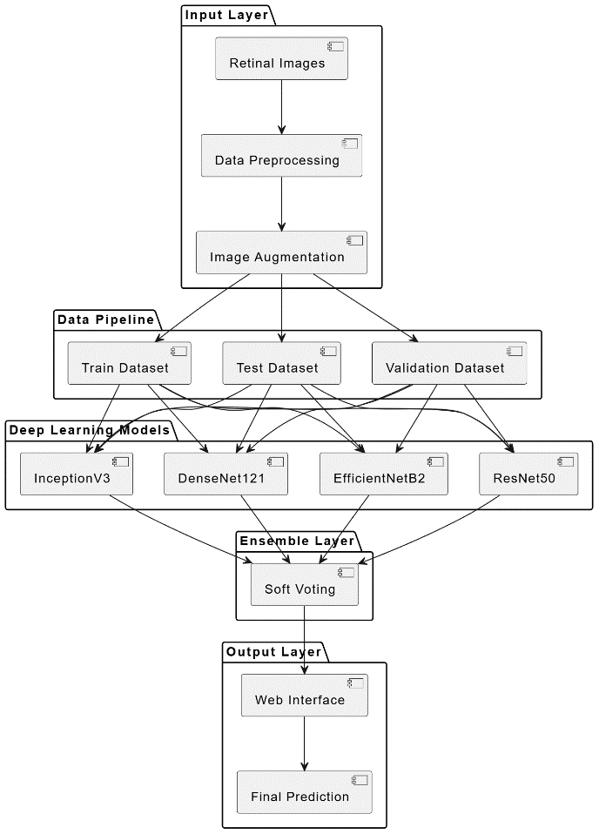

Fig - 1: Architecture Diagram

**5. Gradio Interface:**

**• Image Upload:** A Gradio interface is developed, enabling users to upload images of retina scans.

**• Pre-processing:** The uploaded image undergoes pre-processing identical to that of the training images, including resizing and normalization.

**• Prediction:** The CNN model, which should be saved as CNN.h5, generates a prediction based on the pre-processed image.

**• Output:** The predicted class label (DR or No_DR) is presented to the user.

**Key Improvements and Best Practices:**

**• Stratified Splitting:** Guarantees class balance across training, validation, and testing datasets.

**• Efficient Data Loading:** Utilizes the tf.data API for enhanced image reading and pre-processing efficiency.

**• Transfer Learning:** Employs pre-trained models to accelerate training and enhance performance.

**• Regularization:** Incorporates dropout layers to mitigate the risk of overfitting**.**

**• Ensemble Learning:** Merges predictions from various models to bolster robustness and accuracy.

**•Comprehensive** Evaluation: The confusion matrix and classification report deliver an in-depth performance assessment.

**• User-Friendly Interface:** The Gradio application facilitates straightforward user interaction.

**Results**

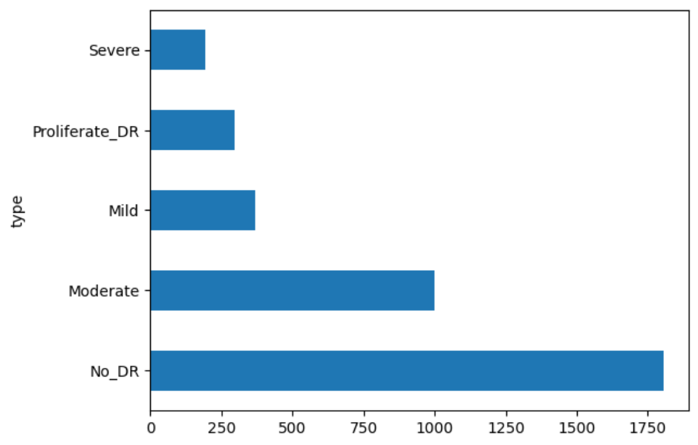

Fig - 2: Distribution of diabetic retinopathy severity levels in the dataset

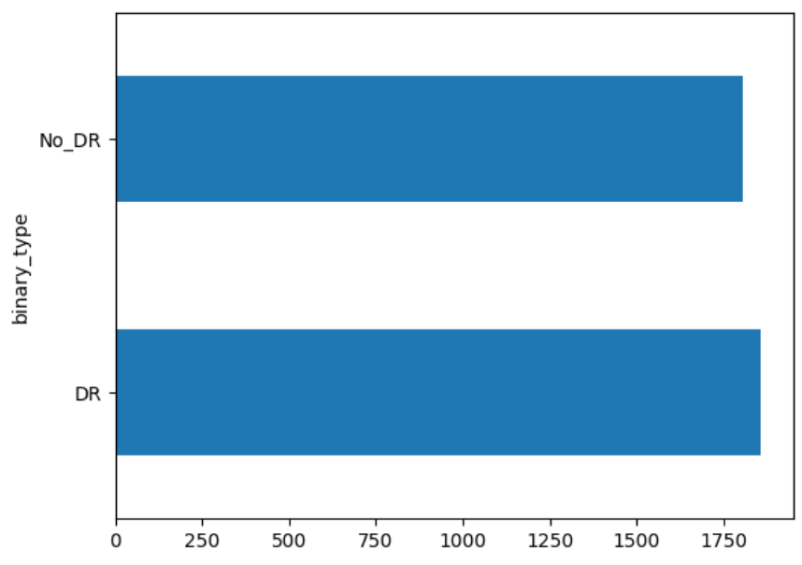

Fig - 3: Binary distribution of diabetic retinopathy cases

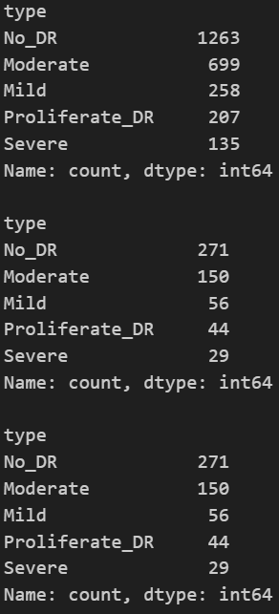

Fig - 4: Class distribution of diabetic retinopathy severity levels across different dataset splits

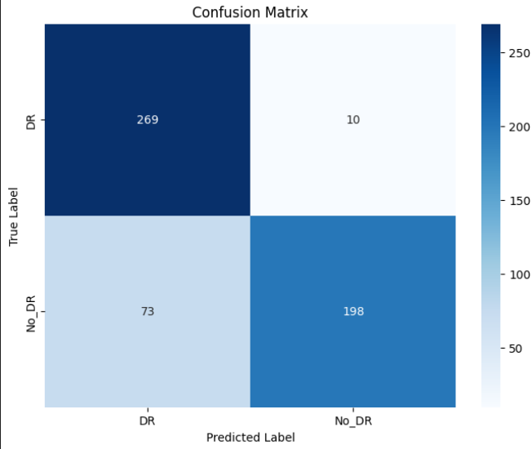

Fig - 5: Confusion matrix illustrating the model's classification performance

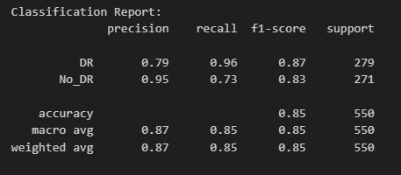

Fig - 6: Classification report summarizing the model's performance

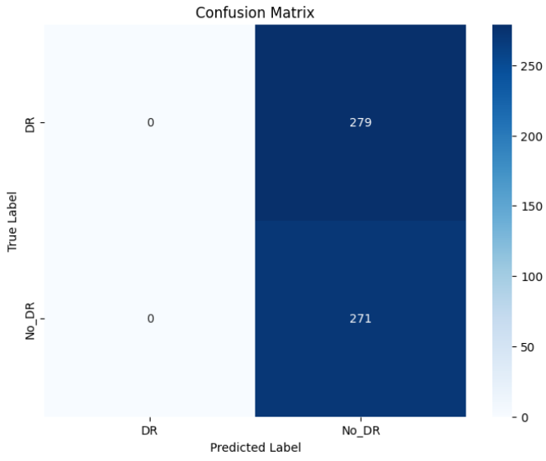

Fig - 7: Confusion matrix indicating a model failure

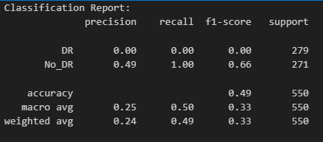

Fig - 8: Classification report showing poor model performance

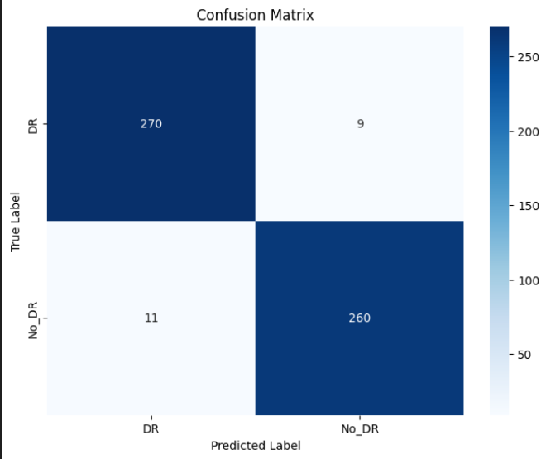

Fig - 9: Confusion matrix demonstrating strong model performance

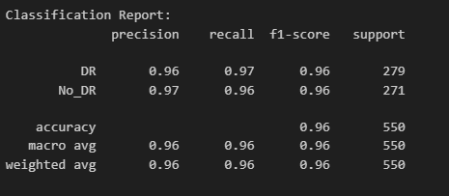

Fig - 10: Classification report indicating excellent model performance

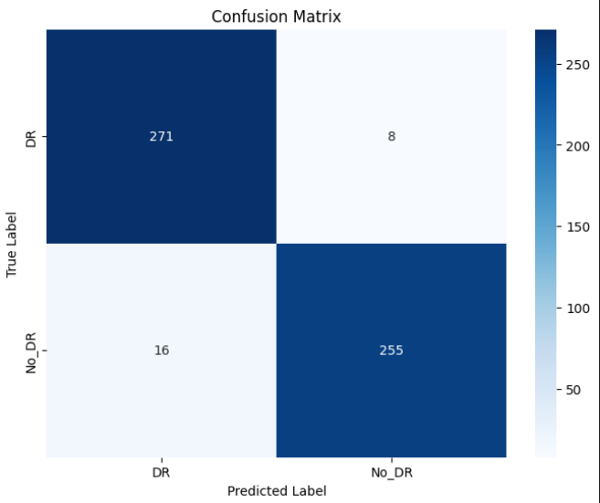

Fig - 11: Confusion matrix showing strong model performance

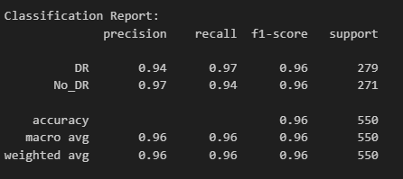

Fig - 12: Classification report demonstrating high model performance

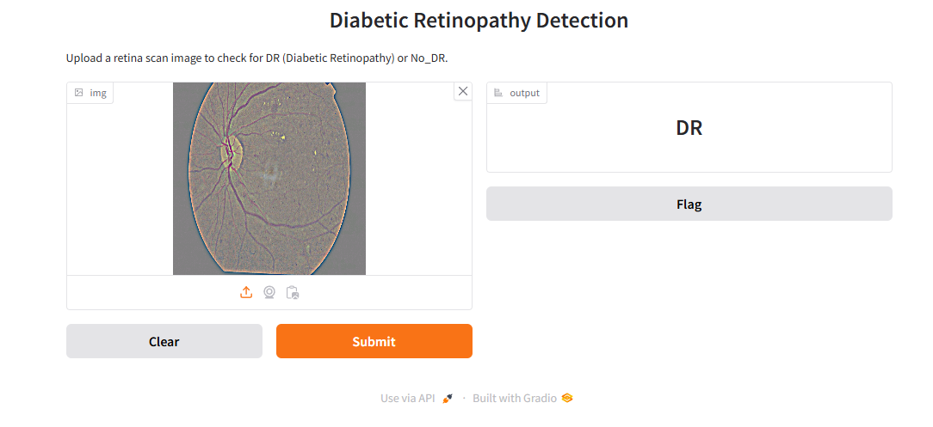

Fig - 13: User interface of a Diabetic Retinopathy detection system built with Gradio, where a retina scan image is uploaded for classification, predicting the presence of DR

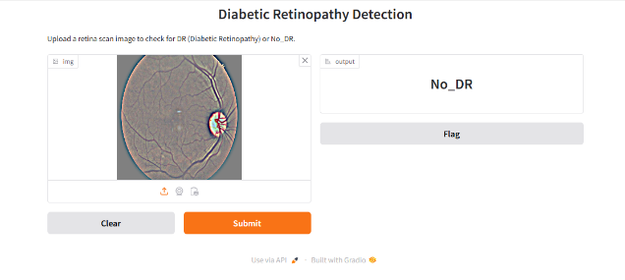

Fig - 14: User interface of a Diabetic Retinopathy detection system built with Gradio, where a retina scan image is uploaded for classification. The model predicts No_DR, indicating no signs of the disease in the provided image**.**

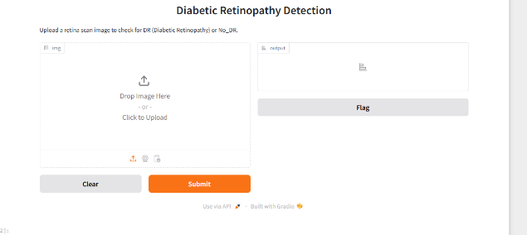

Fig - 15: This is the initial interface of the Diabetic Retinopathy Detection system built with Gradio. It prompts the user to upload a retina scan image for classification as either Diabetic Retinopathy (DR) or No_DR. The interface currently has no image uploaded, and the output field is empty, awaiting input for prediction

**Conclusion**

This initiative centres on the crucial objective of identifying diabetic retinopathy (DR) by utilizing deep learning and ensemble methods. As a significant cause of blindness, the early identification of DR is of utmost importance. The system utilizes transfer learning with several pre-trained models, including ResNet50, EfficientNetB2, DenseNet121, InceptionV3 which are fine-tuned on retinal images to enhance both accuracy and efficiency. An ensemble strategy that incorporates hard and soft voting is employed to bolster robustness and mitigate the risk of overfitting. Data pre-processing steps, such as resizing, normalization, and organized dataset management, are implemented to maintain consistency. The TensorFlow tf.data API is utilized to optimize the handling of large image datasets. A user-friendly Gradio interface facilitates easy image uploads and predictions regarding the severity of DR, thereby improving accessibility. Comprehensive evaluation is performed using confusion matrices and classification reports, which assess precision, recall, and F1-score. Although the models demonstrate encouraging results, potential enhancements such as extended training, fine-tuning of pre-trained weights, and data augmentation techniques (including random rotations, flips, and zooms) could further improve performance. Additionally, hyperparameter tuning and addressing class imbalance through methods like class weighting or oversampling may optimize accuracy. The project also needs to address an issue within the Gradio interface that references a missing "CNN.h5" model file. Ensuring the correct saving and loading of the model will facilitate smooth deployment. Furthermore, enhancing computational efficiency through optimized architectures or knowledge distillation can improve scalability. In summary, this project lays a solid groundwork for DR detection; however, further improvements in model training, data augmentation, hyperparameter tuning, and validation in real-world scenarios are essential prior to clinical implementation.

**References**

[1] **I. Y. Abushawish, S. Modak, E. Abdel-Raheem, S. A. Mahmoud, and A. J. Hussain**, ‘‘*Deep Learning in Automatic Diabetic Retinopathy Detection and Grading Systems: A Comprehensive Survey and Comparison of Methods*,’’ **IEEE Access, vol. 12, pp. 84785–84793, Jun. 2024.** DOI: 10.1109/ACCESS.2024.3415617.

**[2]** **A. M. A. and S. D. Sathya Priya**, ‘‘*A Deep Learning Framework for Detection and Classification of Diabetic Retinopathy in Fundus Images Using Residual Neural Networks*,’’ in Proc. **9th Int. Conf. Smart Comput. Commun. (ICSCC), Aug. 2023**, DOI: 10.1109/ICSCC59169.2023.10335079.

**[3 ]R. Sansare and T. G. Mangave**, ‘‘*Detection of Diabetic Retinopathy (DR) using Fundus Images*,’’ **Int. J. Res. Appl. Sci. Eng. Technol. (IJRASET), vol. 12, no. XI, p. 2179, Nov. 2024**. DOI: 10.22214/ijraset.2024.65554.

**[4] Ritesh Sansare, Tejaswi Ganesh Mangave.** "*Detection of Diabetic Retinopathy (DR) using Fundus Images*." International Journal for Research in Applied Science & Engineering Technology (IJRASET), **Volume 12, Issue XI, November 2024, pp. 2179-2181.** DOI: 10.22214/ijraset.2024.65554.

**[5] Tejas B.K., Pratheek R. Bhat, Srushti S. Pandit, Jaydeb Mitra, Megha V.** "*Detecting Diabetic Retinopathy using Deep Learning*." International Journal of Novel Research and Development (IJNRD), **Volume 7, Issue 9, September 2022**, pp. 1468-1469. Available at www.ijnrd.org

**[6] B. Padma Vijetha Dev, Anampalli Apoorva, Serene Achamma Abraham, Srinidhi Pilli, Sushma Pottipally.** "*RetinaGuard AI: Harnessing SVM, KNN, and Deep Learning for Diabetic Retinopathy Diagnosis*." International Journal of Novel Research and Development (IJNRD), **Volume 9, Issue 1, January 2024**, pp. 179-181. Available at www.ijnrd.org

**[7] Vikash Kumar, Adarsh Patel, Ajay Kumar, Aashutosh Kumar.** "*Diagnosis of Diabetic Retinopathy Using Deep Neural Network.*" International Journal of Novel Research and Development (IJNRD), **Volume 9, Issue 4, April 2024,** pp. 349-351. Available at www.ijnrd.org

**[8] Kumar V, Patel A, Kumar A, Kumar A.** "*Efficiency of EfficientNet and ResNet in Diagnosing Diabetic Retinopathy Using Fundus Images.*" International Journal of Novel Research and Development (IJNRD), **Volume 9, Issue 4, April 2024**, pp. 349-351.

**[9] Shivashish Naithani, Shivam Bharadwaj, Dhiraj Kumar.** "*Automated Detection of Diabetic Retinopathy using Deep Learning.*" International Research Journal of Engineering and Technology (IRJET**), Volume 6, Issue 4, April 2019**, pp. 2945-2947.

**[10] S. Balaji, Dr. R. Ramachandiran, P. Karthikayan, P. Udhayakumar, V. Prathap.** "*An Automated Learning Approach for Detection of Diabetic Retinopathy Using Deep Learning*." International Research Journal of Engineering and Technology (IRJET**), Volume 7, Issue 2, February 2020**, pp. 2826-2828.

**[11] Aryan Kokane, Gourhari Sharma, Akash Raina, Shubham Narole, Prof. Pramila M. Chawan.** "*Detection of Diabetic Retinopathy using Machine Learning*." International Research Journal of Engineering and Technology (IRJET), **Volume 7, Issue 11, November 2020**, pp. 633-635.

**[12] M. Abirami, M. Vignesh, K. Vikramsriram, E. Shivanithyesh.** "*Diabetic Retinopathy Detection using Deep Learning Techniques*." International Research Journal of Engineering and Technology (IRJET), **Volume 8, Issue 5, May 2021**, pp. 1134-1136.

**[13] Sugirtha K, Menaka S R.** "*Deep learning based Automatic Diabetic Retinopathy Detection Using Fundus Images: A Survey*." International Research Journal of Engineering and Technology (IRJET), **Volume 8, Issue 12, December 2021**, pp. 1128-1130.

**[14] Nischit Patel, Kevin Patel, Kunj Patel, Dr. Suvarna Pansambal.** "*Diabetic Retinopathy Detection*." International Research Journal of Engineering and Technology (IRJET), **Volume 9, Issue 4, April 2022**, pp. 482-484.

**[15] Greeshma C Shekar, Chaitanya J M Reddy, HV Rakshitha, Harshitha CS, Keerthana R.** "*Automated Detection of Diabetic Retinopathy Using Deep Learning*." International Research Journal of Engineering and Technology (IRJET), **Volume 9, Issue 5, May 2022**, pp. 305-310.